* Incoming appear in top lane, but are actually in the bottom, collision checks work on the bottom, is just html!

Stats – crashes ok, but speed really bad. Move back to 60? Check anything else, rewards?

1000k steps stats

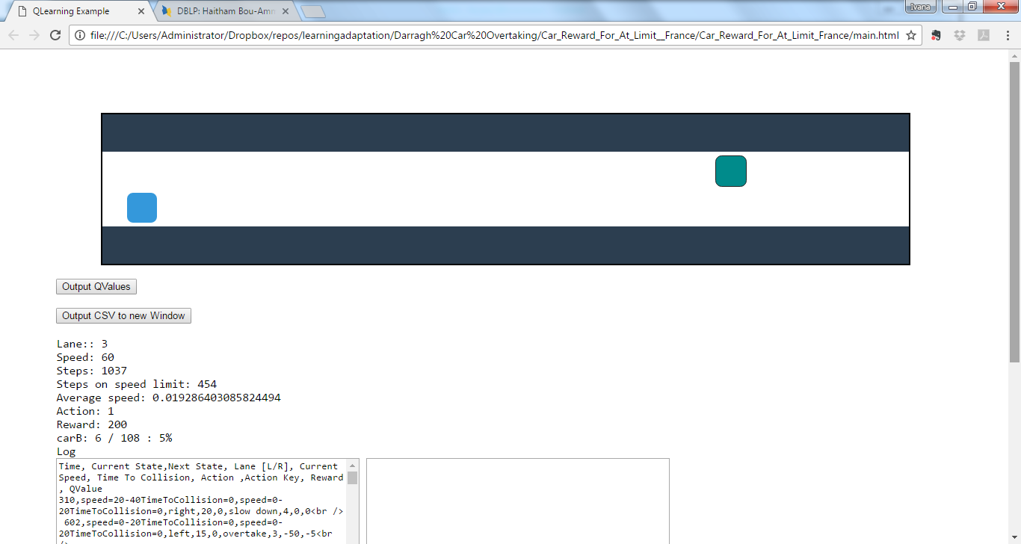

2000k steps stats

